**MedCare StoryBoards**

**Storyboard 1:**

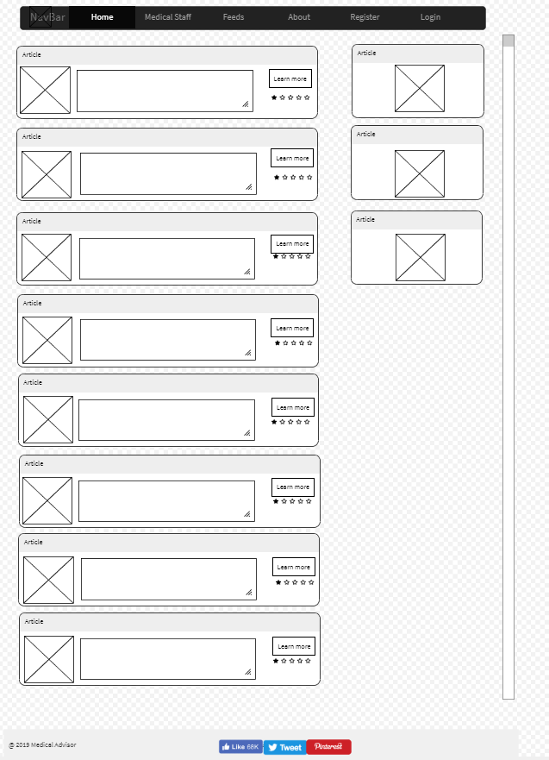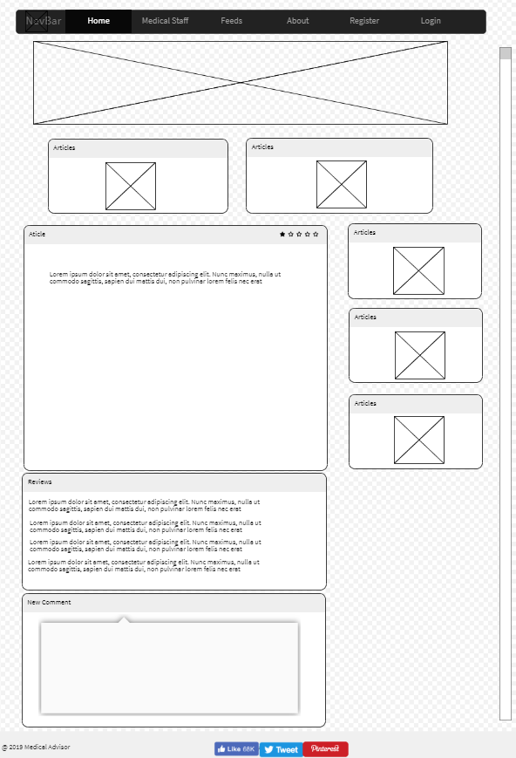

**Storyboard description:** User navigates from Home page (news list page) to News Page (individual news page).

On news page user can navigate through the list of articles posted.

The user can choose one article to read more about it by clicking on “Learn more” button.

On the article site the user can read, appreciate the article by according a rating and by writing a comment about it.

**Storyboard 2:**

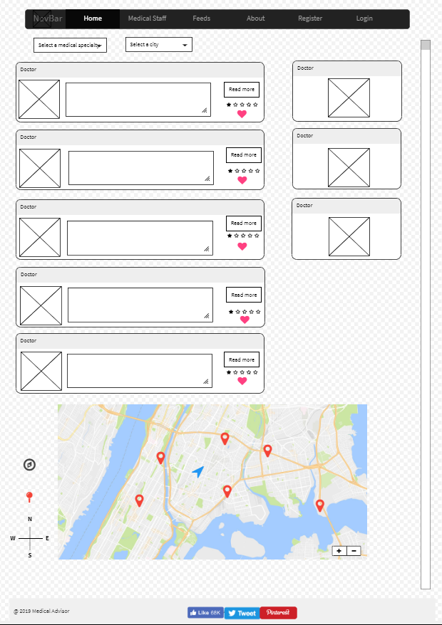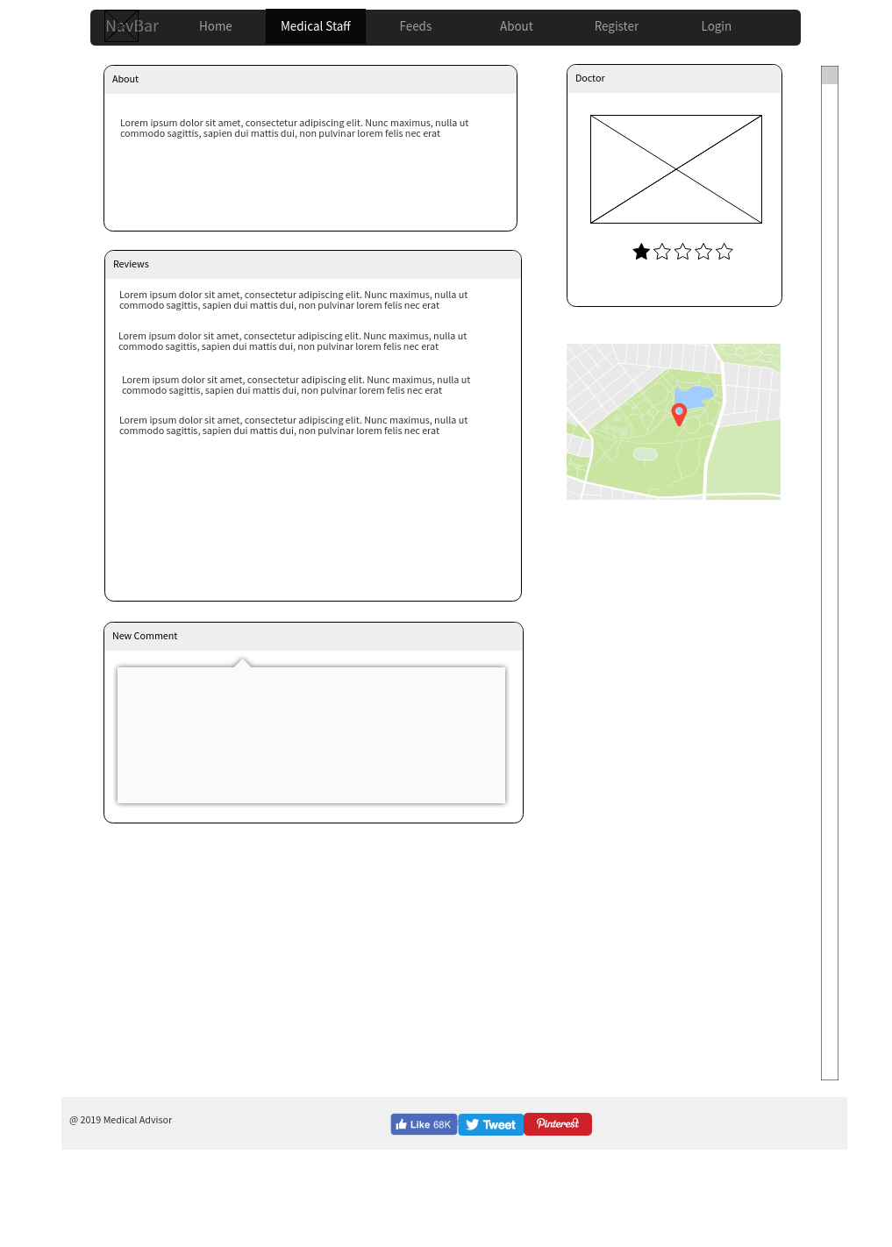

**Storyboard description:** User navigates from Medical Staff page (medical list page) to News Page (individual news page).

Also the user can choose to filter the doctors by specialty and by city. On the right side of the list there are displayed the most active doctors on the site.

And the bottom of the page there is a map with the doctors displayed on the page and the location of user in real time.

From medical list page the user can choose one to see doctors page and details.

On this page user can get information about doctor, the location on map, can give rating and post comments about his experiences with doctor.

**Storyboard 3:**

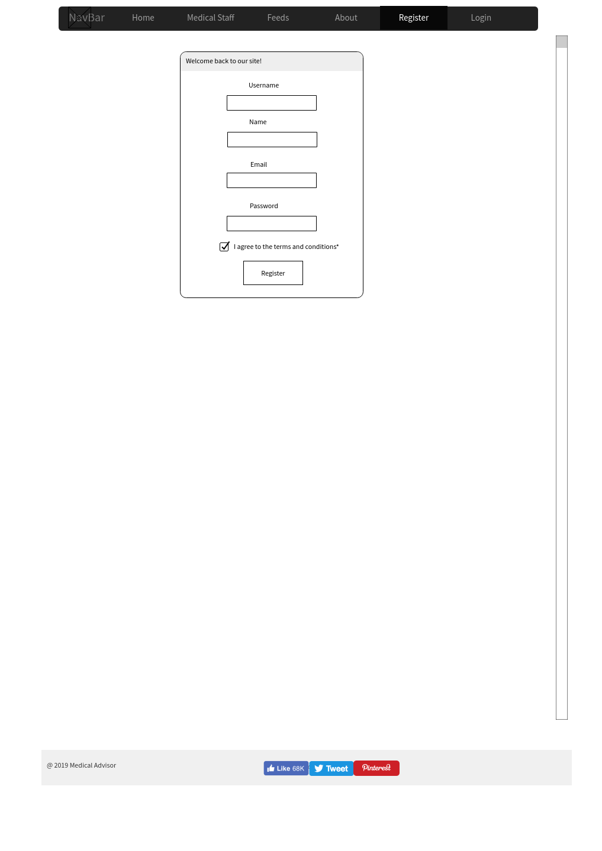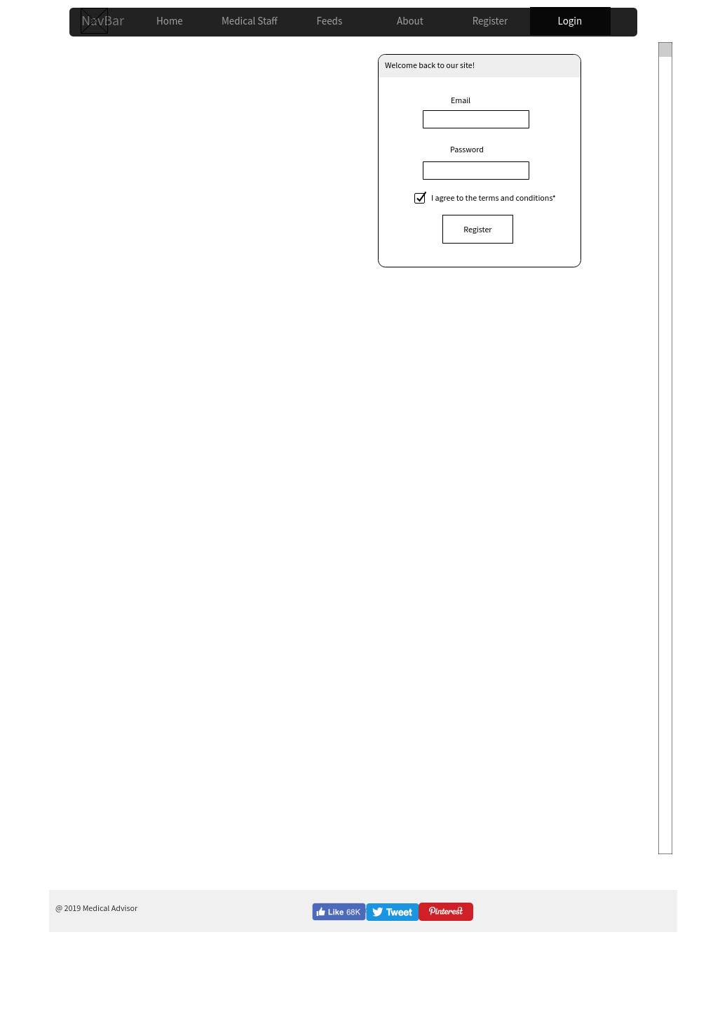

**Storyboard description:** Registration and Login on site

Users must register on site to write comments about doctors or about articles.

After the user registered he must login on the site to have all the privileges of a logged user. Also he can access his profile and edit it. When the user state changes from guest to logged in, the button “Login in” from navigation bar will change from “Login in” to “Logg out”.

**Storyboard 4:**

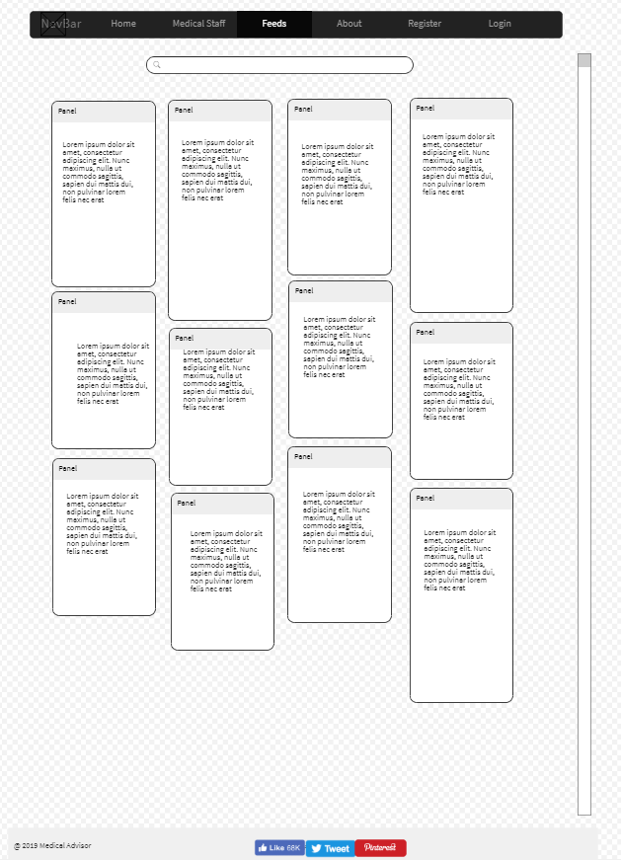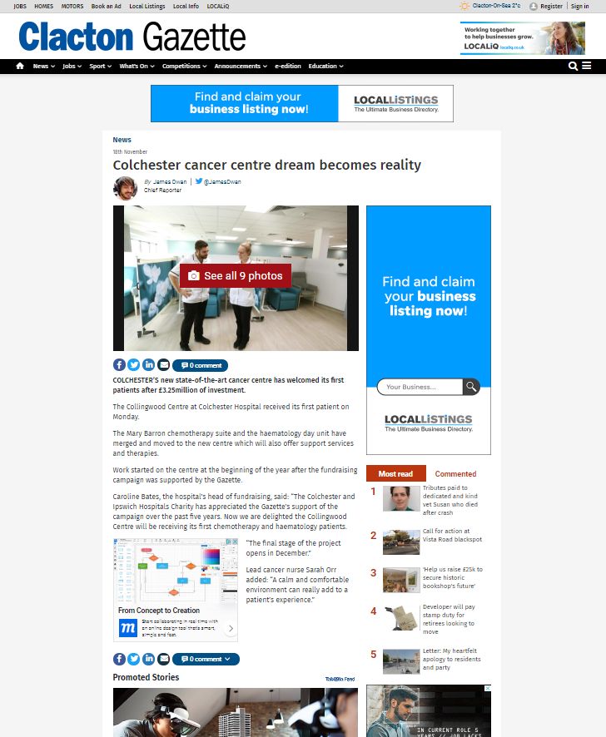

**Storyboard description:** Navigate from Feeds page to RSS Feed website

The Feeds page offers the possibility to search about everything from medical domain. The background API will return all the articles that are related to the terms searched. Each article has a link that will sent user to the website that posted that article.